Strayer University

**APPLICATION ARCHITECHURE**

Week 1

**Project Plan Inception**

for the

Course of

Information Technology Capstone

10/14/18

By

Kennedy Kabaso.

Professor: Barrett Christopher.

**Project Plan Inception**

**Section 2: Gantt Chart / Project Plan**

Use Microsoft Project or an open source alternative, such as Open Project, to:

2.Create a Gantt chart or project plan (summary and detailed) template. The Gantt chart or project plan should:

a. Record all tasks, subtasks, resources, and time related to the project.

b. Outline the planning, analysis, design, and implementation phases.

c. Develop in accordance with the systems development life cycle (SDLC)

**Gantt for our Company**

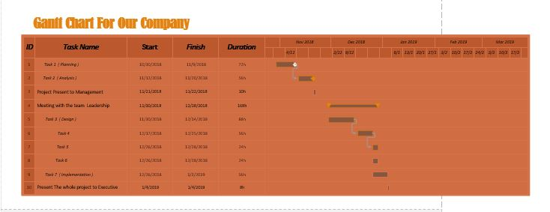

**Gantt Report for our Company**



